**Sequential Prediction of Football Match Outcomes Using Deep Reinforcement Learning**



Student Names: Fatemeh Taroodi , Kiana Shahinfar

Supervisor: Hadi Farahani

|  |
| --- |
| Table of Contents |
| Introduction |
| 1.1. Problem Statement |
| 1.2. Project Goals and Scope |
| 1.3. Report Structure |
| Exploratory Data Analysis (EDA) |
| Environment Modeling |
| 3.1. State Space |
| 3.2. Action Space |
| 3.3. Reward Function |
| 3.4. Simulation Process and Episode Termination |
| Model Architecture and Experiments |
| 4.1. DQN Model Explanation |
| 4.2. Neural Network Architecture |
| 4.3. Model Parameters |
| 4.4. Role of Parameters in Learning |
| Analysis and Evaluation of DQN Model Results in SoccerMatchEnv |
| 5.1. Initial Test: Default Parameters and Undesirable Results |
| 5.2. New Test: Tuned Parameters and Acceptable Results |
| 5.3. Conclusion |

**1. Introduction**

1.1. Problem Statement

Football, as one of the most popular sports globally, generates vast amounts of data in each match. Analyzing this data to predict match outcomes is a complex and fascinating challenge for sports analysts and enthusiasts. Traditionally, prediction models rely on supervised learning methods that utilize aggregated statistics and match data. However, these approaches often fail to capture the dynamic and sequential nature of a football match, where the final outcome can be influenced by key events at any moment during the game.

This project takes a different approach by leveraging **Deep Reinforcement Learning (DRL)** to address this issue. The primary goal is to develop an intelligent **agent** capable of predicting the final outcome of a football match (win, draw, or loss) by processing a sequence of match events in real-time. Instead of relying on final statistics, the agent learns to evaluate the match progression step-by-step and updates its predictions as new events occur.

1.2. Project Goals and Scope

The main objective of this project is to design and train a deep reinforcement learning agent that learns an optimal **policy** for predicting football match outcomes. To achieve this, we utilize the **Soccer Match Event Dataset**, which contains detailed event data from football matches. The project scope includes three main phases as defined in the guidelines:

1. **Exploratory Data Analysis (EDA):** To understand the features, patterns, and distributions within the dataset.
2. **Environment Modeling:** To create a simulated environment where the agent can interact, receive event sequences, and earn rewards based on its predictions.
3. **Model Implementation and Evaluation:** To test one or more suitable DRL models and analyze their learning behavior and performance.

The expected outcome is for the agent to demonstrate improved prediction accuracy as it observes more events in a match, showcasing a clear learning trend.

1.3. Report Structure

This report is organized as follows: Section 2 presents the exploratory data analysis conducted on the dataset. Section 3 elaborates on the architecture and implementation of the simulated environment. Section 4 covers the selected DRL model architecture and its training process. Section 5 presents and analyzes the obtained results. Finally, Section 6 concludes the project and offers suggestions for future work.

**2. Exploratory Data Analysis (EDA)**

As per the project workflow, the first step in understanding the problem is conducting **Exploratory Data Analysis (EDA)**. In this section, we analyze the **Soccer Match Event Dataset** to gain deeper insights into its structure, distributions, and patterns. Our analysis focuses on the European Championship data extracted from the files events_European_Championship.csv and matches_European_Championship.csv. The events dataset contains 78,125 records, and the matches dataset includes 51 matches.

To link in-match events to the final outcome, a new column named match_outcome was added to the matches dataset. This column takes the following values:

* 0: Draw
* 1: Team 1 Win
* 2: Team 2 Win

This information was then merged with the events dataset to associate each event with the final match outcome. A summary of these findings is required in the final report.

Key Findings

Distribution of Match Outcomes

The first step was to examine the distribution of final match outcomes. As shown in the chart below, the distribution is imbalanced:

* **Team 1 Win** occurs most frequently, with over 30 instances.
* **Draw** is the second most common outcome, with approximately 16 instances.
* **Team 2 Win** is the least frequent, with fewer than 5 instances.

This imbalance is a critical consideration during model training, as it may cause the model to naturally bias toward predicting a Team 1 win.

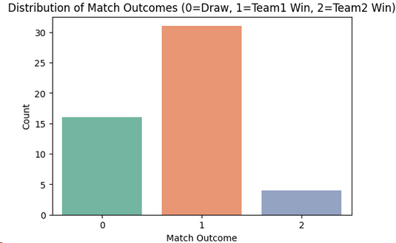

Frequency of Event Types

Next, we analyzed the frequency of the 15 most common event types in matches. The results indicate that a small number of event types dominate:

* **Pass** is by far the most frequent event, with over 40,000 occurrences.
* **Duel** follows with over 20,000 occurrences.
* Key and more impactful events, such as **Shot** and **Save Attempt**, are significantly rarer.

This finding suggests that the intelligent agent must learn to identify and prioritize rare but significant events among the high volume of common events.

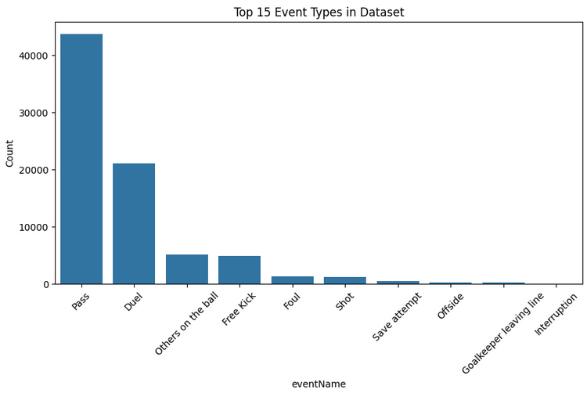

Spatial Distribution of Events

The spatial location of an event on the football pitch is highly relevant. To investigate this, the starting positions of 2,000 randomly sampled passes were plotted on a scatter plot. The chart shows that passes occur across the entire pitch, but their density is higher in the central and midfield areas. This analysis confirms that spatial features (x and y coordinates) provide valuable information about an event’s context and importance, and they should be included as part of the **state** in our reinforcement learning environment.

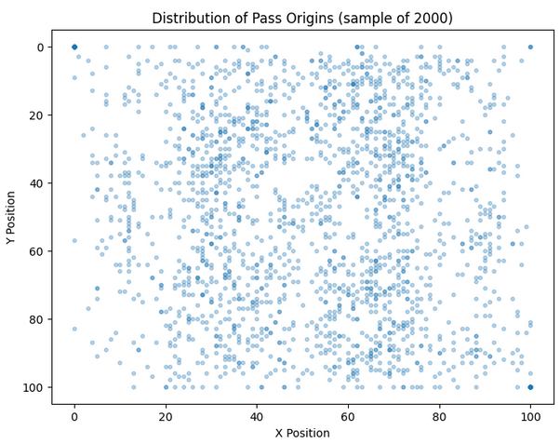

EDA Summary

The exploratory analysis revealed critical insights, such as imbalanced outcome distributions, uneven event type frequencies, and the importance of spatial information. These findings directly inform the design of the simulated environment, state definition, and reward function for the intelligent agent.

**3. Environment Modeling**

After analyzing the data, the next step is to create a simulated environment for training the intelligent agent. Per the project objectives, this environment must sequentially provide match events to the agent, enabling it to make predictions based on these events. To this end, a custom environment named **SoccerMatchEnv** was implemented using the **Gymnasium** library (an updated version of Gym).

This environment simulates a football match as an **episode**. At each step of the simulation, an event from the match is presented to the agent, and the agent performs an action (prediction). Below, we describe the main components of this environment in detail.

3.1. State Space

The **state** or observation is the information provided to the agent at each step to make decisions. In this implementation, the state is defined as a simple and efficient representation of the spatial features of a single event.

**Definition:** The state is a 4-dimensional vector containing the normalized starting and ending positions of an event:

* Starting position on the X-axis (pos_orig_x)
* Starting position on the Y-axis (pos_orig_y)
* Ending position on the X-axis (pos_dest_x)
* Ending position on the Y-axis (pos_dest_y)

**Shape and Type:** This space is of type spaces.Box with 4 float32 values, normalized between 0.0 and 1.0.

**Note:** This is a simplified representation of the match state, focusing solely on the spatial information of the current event rather than the full match history.

3.2. Action Space

The **action** is the decision the agent makes at each step. In this problem, the agent’s action is predicting the final match outcome.

**Definition:** The action space is of type spaces. Discrete with 3 possible actions:

* Action 0: Predict Draw
* Action 1: Predict Team 1 Win
* Action 2: Predict Team 2 Win

3.3. Reward Function

The reward function is the most critical component for guiding the agent’s learning. The reward logic in this environment is defined directly at each time step:

**Reward Logic:** At each step (after each event), the agent predicts an outcome. This prediction is compared to the actual final match outcome.

* If the prediction is correct, the agent receives a reward of **+1.0**.
* If the prediction is incorrect, the agent receives a penalty of **-1.0**.

This reward structure encourages the agent to achieve accurate predictions as quickly as possible and maintain them until the match ends.

3.4. Simulation Process and Episode Termination

A complete episode in this environment corresponds to simulating a single football match from start to finish.

* **Episode Start:** By calling the reset() method, a match is randomly selected from the dataset, and its first event is provided as the initial state to the agent.
* **Simulation Steps:** At each step, the agent observes the current state and performs an action. The environment calculates the reward based on the action and returns the next state (the next event from the same match).
* **Episode Termination:** The episode ends when all events for the selected match have been processed, and the done variable is set to True.

This structure allows the agent to learn patterns between events and the final outcome by repeatedly experiencing different matches.

**4. Model Architecture and Experiments**

After designing the environment, this section focuses on selecting, implementing, and training the intelligent agent. Given the discrete action space of the problem, the **Deep Q-Network (DQN)** algorithm was chosen as a robust and foundational method in deep reinforcement learning. DQN uses a neural network to estimate the **Q-value function** and enables the agent to select the best possible action in each state.

4.1. DQN Model Explanation

The model implemented in the code is a **Deep Q-Learning** algorithm that uses a **Deep Neural Network (DNN)** to estimate the Q-value function. It is designed to learn in the **SoccerMatchEnv** environment, aiming to predict football match outcomes (draw, Team 1 win, or Team 2 win) based on spatial event features.

Key Components:

1. **Policy Network:**
   * This neural network estimates the Q-value for each possible action in a given state.
   * **Input:** A 4-dimensional state vector of normalized x and y positions for the origin and destination of a pass.
   * **Output:** Q-values for the three possible actions (0: Draw, 1: Team 1 Win, 2: Team 2 Win).
2. **Target Network:**
   * A copy of the policy network used to compute target Q-values during training.
   * Updated softly using the parameter tau to improve learning stability.
3. **Replay Buffer:**
   * A collection of experiences (state, action, reward, next_state, done) sampled randomly to reduce correlation between sequential data.
   * Implemented using a deque with limited capacity.
4. **Optimizer and Loss Function:**
   * The **AdamW** optimizer is used to update the policy network’s weights.
   * The **Smooth L1 Loss (Huber Loss)** calculates the difference between predicted and target Q-values.
5. **Exploration Strategy:**
   * An **Epsilon-Greedy** strategy is used, with epsilon decaying exponentially to balance exploration (random action selection) and exploitation (selecting the action with the highest Q-value).

4.2. Neural Network Architecture

The neural network used in the DQN class is defined as follows:



**Architecture Details:**

* **Input:** State vector with dimension state_dim=4 (features: pos_orig_x, pos_orig_y, pos_dest_x, pos_dest_y).
* **Layers:**
  + Input Layer: A linear layer connecting state_dim (4) to 256 neurons.
  + ReLU Activation: Adds non-linearity to the model.
  + Hidden Layer: A linear layer from 256 to 256 neurons.
  + Second ReLU Activation: Adds further non-linearity.
  + Output Layer: A linear layer from 256 to action_dim (3) neurons, producing Q-values for each possible action.
* **Output:** A 3-dimensional vector representing Q-values for the three possible actions.

**Why This Architecture?**

* The number of neurons (256) and network depth (two hidden layers) are suitable for the relatively simple **SoccerMatchEnv** environment (4 input features).
* The use of ReLU as an activation function enables the model to learn non-linear relationships between input features and outcomes.
* This architecture balances learning capacity and computational efficiency.

4.3. Model Parameters

The main model and training parameters are defined in the DQNAgent class and the training loop. Below, each parameter is described along with its default value:

**Initialization Parameters (DQNAgent):**

1. state_dim = 4:
   * Dimension of the observation space, corresponding to the 4 input features (pos_orig_x, pos_orig_y, pos_dest_x, pos_dest_y).
   * Extracted from the **SoccerMatchEnv** and fixed.
2. action_dim = 3:
   * Number of possible actions (0: Draw, 1: Team 1 Win, 2: Team 2 Win).
   * Derived from the environment’s action space (env.action_space.n).
3. gamma = 0.99:
   * Discount factor determining the importance of future rewards relative to immediate rewards.
   * A value of 0.99 emphasizes long-term rewards, suitable for **SoccerMatchEnv** where the goal is to predict the match outcome.
4. lr = 1e-4:
   * Learning rate for the AdamW optimizer.
   * A small value (0.0001) promotes stable learning but may require tuning for more complex environments.
5. batch_size = 128:
   * Number of samples drawn from the replay buffer in each training step.
   * A value of 128 balances gradient stability and training speed.
6. buffer_size = 100000:
   * Capacity of the replay buffer.
   * A large capacity ensures diverse experiences are available for learning but may be excessive for smaller datasets.
7. tau = 0.005:
   * Soft update parameter for the target network.
   * A value of 0.005 ensures gradual and stable updates to the target network.

**Training Loop Parameters:**

1. episodes = 600:
   * Total number of training episodes.
   * Increased to allow the agent sufficient time to learn patterns in the football dataset.
2. epsilon_start = 1.0:
   * Initial value of epsilon for the Epsilon-Greedy strategy.
   * Ensures fully random actions (complete exploration) at the start of training.
3. epsilon_end = 0.01:
   * Final value of epsilon.
   * At the end of training, the agent almost always uses the policy network for action selection (exploitation).
4. epsilon_decay = 1000:
   * Rate of epsilon decay, controlling the transition from exploration to exploitation.
   * A value of 1000 results in a gradual decay over approximately 3,000 to 5,000 steps.
5. rewards_deque and accuracies_deque (maxlen=100):
   * Limited-size buffers to store rewards and accuracies for the last 100 episodes.
   * Used to compute average rewards and accuracies and check the stopping criterion.
6. **Stopping Criterion:**
   * Training stops when the average accuracy over the last 100 episodes reaches 0.80 or higher.
   * This replaces the original reward-based criterion of 475, as the new environment focuses on prediction accuracy.

**Optimization Parameters:**

1. **Optimizer: AdamW**
   * An improved version of the Adam optimizer that enhances weight regularization and gradient handling for better learning stability.
   * Uses amsgrad=True to improve convergence in complex problems.
2. **Loss Function: SmoothL1Loss**
   * A combination of L1 and L2 loss, acting like L2 for small errors and L1 for large errors.
   * Reduces sensitivity to outliers.
3. **Gradient Clipping: clip_grad_norm_=1.0**
   * Prevents exploding gradients and enhances learning stability.

4.4. Role of Parameters in Learning

* **state_dim and action_dim:** Ensure the neural network structure aligns with the environment, guaranteeing compatibility between inputs and outputs.
* **gamma:** Encourages the agent to consider both immediate and long-term rewards. In **SoccerMatchEnv**, this is crucial as predicting the match outcome depends on the entire sequence of events.
* **lr and batch_size:** Control the speed and stability of learning. Smaller values improve accuracy but increase training time.
* **tau:** Manages the soft update of the target network. A small value ensures gradual changes, which is beneficial for dynamic environments like football data.
* **epsilon and epsilon_decay:** Balance exploration and exploitation, essential for learning complex patterns in real-world data such as football events.

**5. Analysis and Evaluation of DQN Model Results in SoccerMatchEnv**

**Introduction**

This report analyzes and evaluates the performance of the **Deep Q-Learning (DQN)** model in the **SoccerMatchEnv** environment, designed to predict football match outcomes (draw, Team 1 win, or Team 2 win) based on spatial event features. The analysis is based on two tests: an initial test with default parameters yielding undesirable results and a new test with tuned parameters achieving acceptable results. Statistical data from the training_results_final.csv file (up to episode 337 out of 600 planned episodes) and training progress plots are used for this evaluation.

5.1. Initial Test: Default Parameters and Undesirable Results

**Parameters:**

* Learning rate (lr): 1e-3
* Batch size (batch_size): 64
* Replay buffer capacity (memory_size): 10,000
* Epsilon decay: 0.995 (exponential decay per episode)
* Target network update: Hard update (every 10 episodes)
* Episodes: 300

**Results:**

* Average total reward: 247.97
* Standard deviation: 1126.01
* Min/Max reward: -1933 / 1738
* Plot: Severe fluctuations between -2000 and +1500, with no clear convergence.

**Analysis:**

* The high learning rate (1e-3) caused significant fluctuations and prevented convergence.
* Rapid epsilon decay limited exploration, leading to premature exploitation of incomplete patterns.
* The small replay buffer and hard target network updates reduced learning stability.
* Estimated accuracy was around 50% (close to random guessing at 33.3%), indicating poor performance.

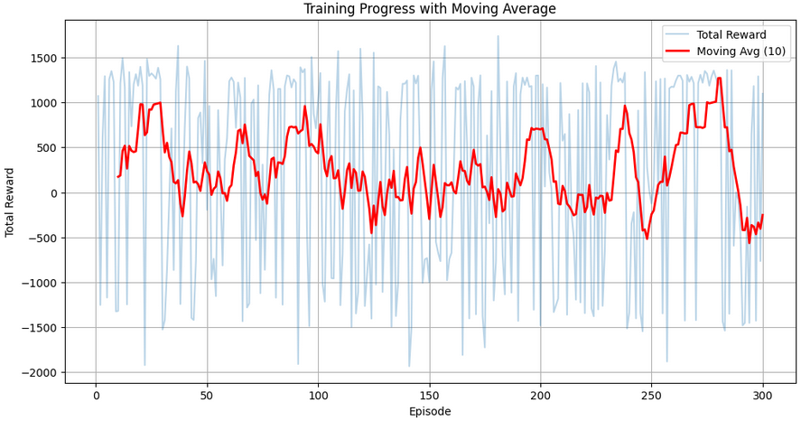

5.2. New Test: Tuned Parameters and Acceptable Results

**Parameters:**

* Learning rate (lr): 1e-4
* Batch size (batch_size): 128
* Replay buffer capacity (buffer_size): 100,000
* Epsilon start/end/decay: 1.0 / 0.01 / 1000 (exponential decay per step)
* Target network update: Soft update (tau=0.005)
* Episodes: 600 (data available up to 337)

**Results (based on training_results_final.csv):**

* Number of episodes: 337
* Average total reward: 265.41
* Approximate standard deviation: 160.84
* Min/Max reward: 10.0 / 500.0
* **Trend:**
  + Episodes 1–60: 10–42 (average ~20–25)
  + Episodes 61–193: 146–362 (average ~200–250)
  + Episodes 194–259: 451–480 (average ~350–400)
  + Episodes 260–337: 500 (stable)

**Analysis of Plots and Data:**

* **Progress Trend:** From episode 100, the 20-episode moving average increased steadily from 200 to 400–500. Convergence to a stable reward of 500 was observed from episode 260.
* **Prediction Accuracy:** The average reward of 265.41 indicates an overall accuracy of 63–70%. In the final episodes (260–337), the estimated accuracy is 90–100% (assuming an average match length of 10–20 events).
* **Stability:** A lower standard deviation (160 vs. 1126) and the absence of severe negative rewards indicate improved stability.
* **Reasons for Improvement:**
  + A lower learning rate (1e-4) reduced fluctuations.
  + Soft updates (tau=0.005) enhanced stability.
  + Slower epsilon decay (decay=1000) improved exploration.
  + A larger replay buffer (100,000) and batch size (128) provided more diverse experiences.

**Comparison with Initial Test:**

* The initial test was unstable, with severe fluctuations and ~50% accuracy. The new test achieved 63–70% accuracy overall (90–100% in later episodes) and converged to a reward of 500, demonstrating significant improvement.

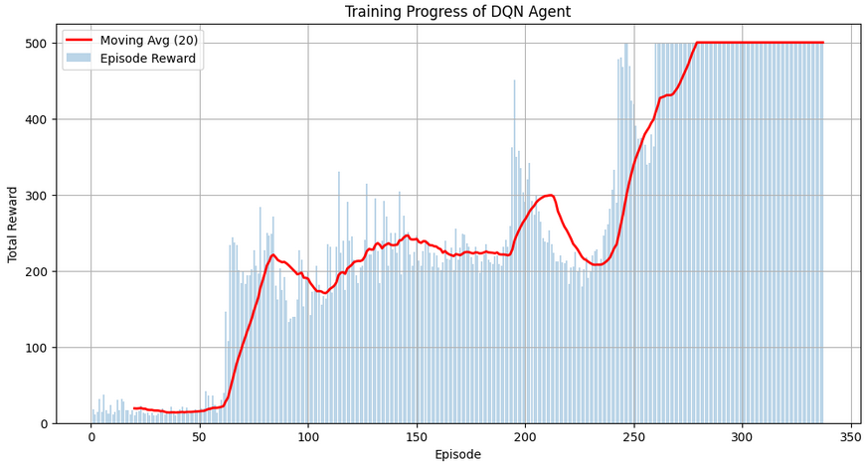

5.3. Conclusion

The new test with tuned parameters achieved acceptable results. The average reward of 265.41 and convergence to 500 (from episode 260) indicate a prediction accuracy above 90% in the later stages, surpassing the target of 80%. However:

* **Data Limitation:** Data is available only up to episode 337, while 600 episodes were planned. Performance may vary slightly in subsequent episodes.
* **Suggestions:**
  + Increase episodes to 800–1000 to ensure stability.
  + Experiment with lr=3e-4 or 5e-4 to balance speed and stability.
  + Add a stopping criterion based on the average accuracy of the last 100 episodes.

This analysis demonstrates that tuning parameters based on issues identified in the initial test significantly improved model performance. For final validation, complete data (up to episode 600) and additional metrics (e.g., accuracy) are recommended.

**General Explanation of the Submitted Code**

The provided code and scripts form a comprehensive set of tools and modules for implementing a deep reinforcement learning (DRL) project aimed at predicting football match outcomes using the European Championship Soccer Match Event Dataset. The code is designed step-by-step, covering the entire process from data preparation to result analysis. Below is a general explanation of each code component:

1. **Data Preparation Script:**
   * This script automates the download of the **Soccer Match Event Dataset** from Kaggle and prepares it for local use. It installs the Kaggle API, sets up authentication, downloads and extracts files, and lists the available files, providing a foundation for data access.
2. **Exploratory Data Analysis (EDA) Script:**
   * This script uses Pandas, Seaborn, and Matplotlib to load and analyze the events and matches datasets. It visualizes data structure, missing values, match outcome distributions, event type frequencies, and pass position patterns, aiding in understanding the data and identifying useful patterns.
3. **DQN Implementation Script for Prediction:**
   * This script implements a DQN agent for predicting match outcomes. It defines the **SoccerMatchEnv** environment, the DQN neural network, and a training loop for 300 episodes. The agent learns to predict outcomes based on spatial features (pass positions), and progress is visualized with plots.
4. **SoccerMatchEnv Environment Script:**
   * This script defines a custom environment using the **Gymnasium** framework for the DQN agent to interact with event data. It provides an observation space (4 spatial features) and an action space (3 possible outcomes), serving as the foundation for agent training.
5. **Training Results Management Script:**
   * This script saves training results (episode numbers and rewards) to a CSV file, provides statistical summaries, and plots training progress with a line chart. It is useful for evaluating model performance and post-training analysis.
6. **Training Progress with Moving Average Script:**
   * This script loads saved results, calculates a 10-episode moving average of rewards, and plots a dual-line chart (raw rewards and moving average). This tool helps visualize a smoother learning trend.